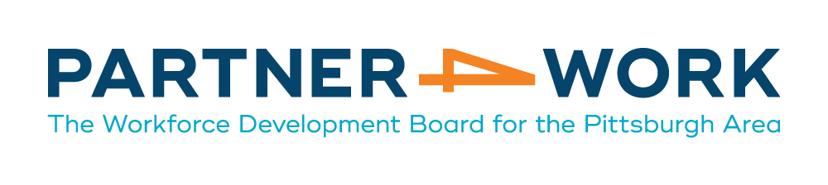
2018 Provider RFP

- Should the budget and program description for this proposal reflect a one-or three-year period?

Partner4work Answer: Provider budgets and program descriptions should reflect a 1-year period.

- Is there a page limit to the proposal?

Partner4work Answer: The provider proposal can be as long as necessary to describe the employment program while also completing all of the requirements specified in the RFP.

