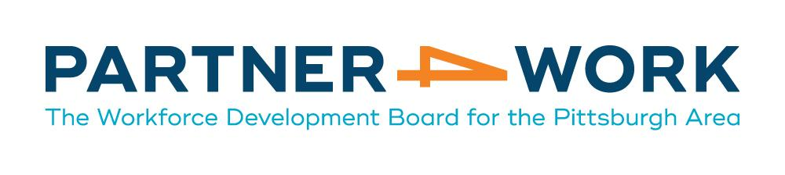
PATHWAY HOME PROGRAM
SUPPORTIVE SERVICES POLICY

Purpose

The Pathway Home program aims to assist returning citizens in the reintegration process and reduce recidivism through pre- and post-release services in occupational training, career-specific work readiness activities, and meaningful employment opportunities by utilizing the public workforce system’s extensive employer networks to cultivate direct employer connections. By implementing these strategies in tandem comprehensive case management and supportive services, this program intends to provide industry-recognized credentials and successful employment placement in order to lower recidivism rates for justice-involved participants across Allegheny County.

The purpose of this policy is to articulate how supportive services are to be offered to participants in the US Department of Labor Pathway Home program in Allegheny County.

Affected Parties

This policy applies to all Pathway Home participants. Pathway Home staff are responsible for implementing this policy.

References
WIOA Section 3(59)
20 CFR §680.900
Pathway Home - FOA-ETA-20-02
Midwest Urban Strategies - Partner Handbook (DOL Pathway Home PE-35039-20-60-A-55 program)

Definition of Key Terms

“Supportive Services” are services designed to provide a participant with the resources necessary to enable their participation in activities and achieve program goals under the Pathway Home program.

“Needs related payments” provide financial assistance to enable individuals to participate in training activities. Partner4Work is currently not providing needs related payments to Pathway Home participants.

Eligibility Requirements

The following are supportive service eligibility requirements for Pathway Home participants:
● Participant must be a Pathway Home eligible participant.
● Participant must be participating in Pathway Home program services or activities.
● Participant must be unable to obtain supportive services through other programs providing such services.

Policy

Pathway Home program staff should meet with each participant to assess the need for supportive services. Each participant should be given individualized case management services and plan development in order to eliminate possible dependency on supportive services. Supportive services awards should be based on individual participant needs and plan development. This information should be properly documented in the Individual Employment Plan (IEP) and case notes in each participant’s case file. Supportive services may only be awarded when necessary to enable participation in Pathway Home program services or activities. P4W funds must be used in accordance with the requirements of the Federal Uniform Guidance and all other guidance and regulations applicable to the funding source.

Because funds should only be used to provide supportive services when they are unavailable through other resources and service providers, Pathway Home program staff are responsible for coordinating services and providing referrals to other state and local agencies offering supportive services. Pathway Home program staff must ensure that all other avenues and resources have been exhausted prior to expending Pathway Home funds for supportive services. Staff must provide documented proof of the service being unavailable in the area through other resources including PA 211 Southwest (http://pa211sw.org/).

Partner4Work WIOA Supportive Services Availability:

Partner4Work will only provide funding for the below list of supportive services to Pathway Home participants. Pathway Home staff will determine the need for supportive services and monitor the customer’s progress and status to assess ongoing need.

1. Transportation – Supportive services funds may be used to cover certain transportation costs, including a.) Bus passes, not exceeding Allegheny Port Authority’s monthly fare; b.) Gas cards, not exceeding $25 per week.
2. Driver’s license or state identification card: A Pathway Home participant may receive supportive services funds for one (1) instance of the cost of obtaining a state driver’s license or identification card. Supportive service funds may not be used to pay for the costs of fines, penalties, or legal fees associated with obtaining or reinstating a driver’s license.
3. Non-employer paid licensing/certification or educational testing fees: A Pathway Home participant may receive funding for a maximum of two (2) instances of the same license/certification or test utilizing Pathway Home supportive services dollars. Pathway Home program staff will determine the need for licensing or testing through employer demand. The staff will make the necessary arrangements with the vendor for payment. The cost of GED testing and/or obtaining GED transcripts may be covered under this supportive services category.
4. Drug Testing and/or TB Testing: A Pathway Home participant may have drug tests and/or TB tests paid for through Pathway Home supportive services dollars.
5. Criminal Background Checks and/or Clearances: A Pathway Home participant may have criminal background checks and/or clearances necessary to begin employment and/or education paid through Pathway Home supportive services dollars. This includes each of the following: Pennsylvania Child Abuse History Clearance, Pennsylvania State Police Criminal Record Checks, and Federal Bureau of Investigations (FBI) Criminal History Background Check.
6. Clothing and/or uniform: A Pathway Home participant may receive one (1) voucher for up to $100 to purchase clothing and/or a uniform(s) necessary for participation in training, a job interview, or the first week of employment if these items are not provided by the training provider or employer.
7. Equipment/tools: A Pathway Home participant may receive one (1) voucher for up to $250 to cover the costs of tools and/or equipment necessary for participation in training or the first week of employment if these items are not provided by the training provider or employer.
8. Unions and Registered Apprenticeships Fees: A Pathway Home participant applying to a union and/or registered apprenticeship may receive assistance for non-employer paid, non-refundable costs required for initial admittance or participation in the program. These costs may include application fees, initial dues (one month only), and/or required clothing/shoes. Supportive services funds may only be used if the expenses are a requirement for participation in training and/or a reasonable condition of employment.
9. Reasonable accommodations for individuals with disabilities —Pathway Home supportive services dollars may only be used as the funding of last resort for these accommodations.

Policy Exceptions
Under limited circumstances, Partner4Work may grant exceptions to requirements within this policy. Requests for exceptions may be submitted to kkadisevskis@partner4work.org (Special Projects Director). Requests should include the following:

- The specific policy requirement for which an exception is being requested;
- A clear summary of the exception being requested and the reason for the exception; and
- The full name of the participant(s) for which an exception is being requested; or
- The name and FEIN of the business customer for which an exception is being requested.

Exception requests will be reviewed based on their allowability under the USDOL Pathway Home program and any other applicable legislation, regulation, and policy/guidance. Partner4Work will also consider funding availability, how an exception will lead to improved outcomes for the customer(s) being served, and other relevant factors.

Effective Date: November ____, 2020

